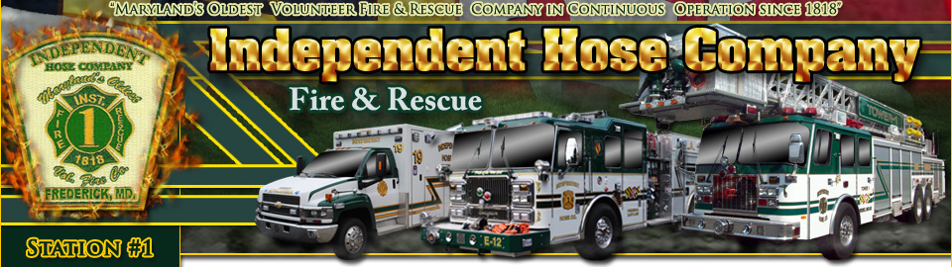

IHC BIG MONEY BINGO
PURCHASE TICKETS HERE
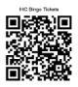

When: Sunday, October 18, 2026

Where: Independent Hose Company
310 Baughmans Lane
Frederick, MD 21702

Ticket Costs: $ 55.00 prior to 10/18/2026
$ 65.00 at the door (if available)
Reserved seating upon request – send email to ihc.bingo@gmail.com

What’s included: 9 pack for 20 games (2 Jackpot Games included in ticket price)
**Extra papers will be available for purchase**
Water and coffee (bring your own favorite drinking cup)

Schedule of events: Doors open @11am, Snack bar opens @11:30, Bingo games start @1:00pm (Some ball games may be played before Bingo starts so get there early)

- 16 Games will pay $500.00* per game
- Last game each half pays $1000.00*
- 2- special gift games (1 per half) included w/ ticket
- 2- 50/50 games (1 per half) - Sold Separately
- 2- Winner takes ALL Special games (1 per half) - Sold Separately
- Ball games & holder card games will be sold starting at 11am
- No refunds unless IHC cancels bingo and does not reschedule for any reason
- Must have purchased a ticket with a minimum 9 pack to win
- No one under 18 can win cash
- No outside food allowed - Snack bar will be open to purchase food/snacks/drinks

Purchase tickets by using the following:
- QR code above or online @ www.ihc-1.org
- Email ihc.bingo@gmail.com (Give name, how many tickets you want to purchase, and date of bingo)
- Call or Text Connie @ 240-626-4624
- Purchase tickets from a member of the fire company

*IHC reserves the right to modify the payouts based on the number of bingo tickets sold.

